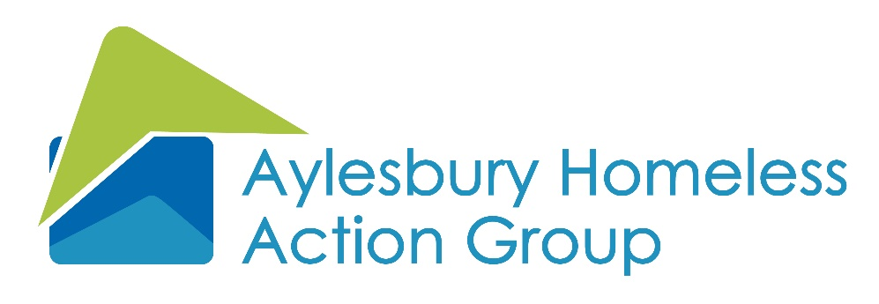

Report a safeguarding concern

This form should be used to record safeguarding concerns relating to vulnerable adults and/or children. In an emergency please do not delay in informing the police or social care. All the information on this form must be treated as confidential and reported to the Safeguarding Lead (James Boultbee – james@ahag.org.uk) and the Safeguarding Trustee (Sue Giles – sue.giles@buckinghamshire.gov.uk) within one working day or the next working day if it is a weekend.
The form should be completed at the time or immediately following disclosure, but after all necessary emergency actions have been taken. Please complete the form as fully as possible.

- Your details – the person completing the form

Name: Position:

Telephone: Email:

- Details of the person affected

Name:

Address:

Telephone: Email:

- Details of the incident (please describe in details using only the facts)

- Others present or potential witnesses

- Additional relevant information

I have completed this form and provided information that is factual and does not contain my own views or opinions on the matter.

Print name: Date:

Signature:

